How to Perform the Seated Row

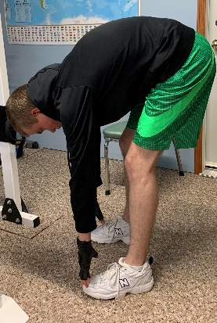
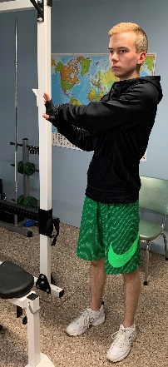
- Before performing any exercise remember to thoroughly stretch the muscle groups that you will be working.

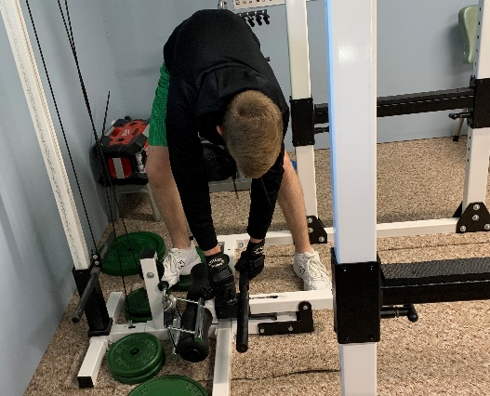
- Once warmed up, proceed with setting yourself up at the required row station. Do this by adjusting seat/footrest, and by organising the weights that will be added as sets go on.

- For your first set, add 50% of your estimated maximum weight to the pulley system.
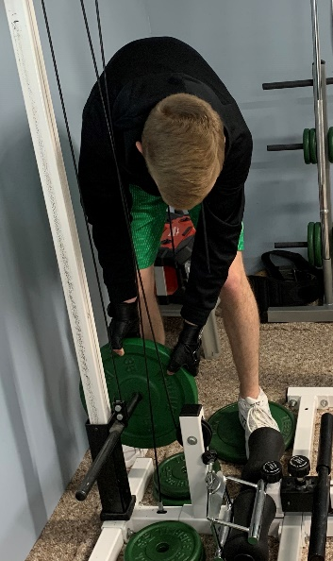

- Next you will sit down on the bench or the floor, with your feet flat on the foot platform/footrest. You will lean forward and grab onto the seated row handles attached to the pulley system.
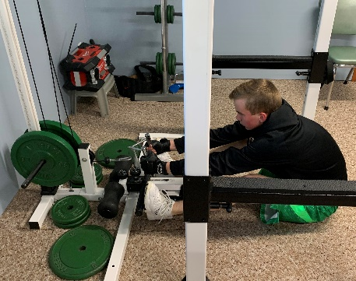

- Your next step while you are holding the handles, is to straighten your back perpendicular to the floor. This will cause a pulling force on your arms but concentrate on pulling with your lower back muscles.
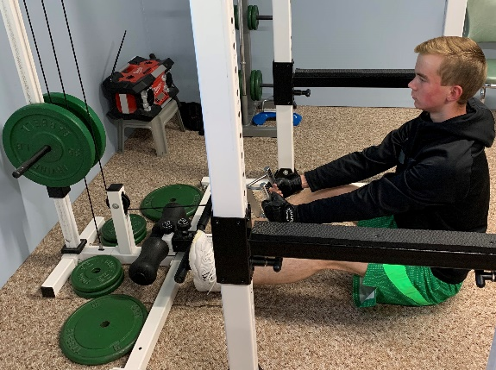

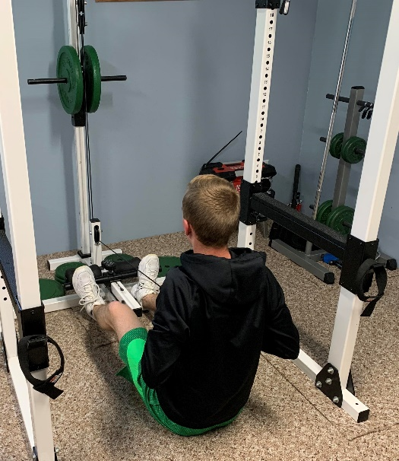
- After performing the previous step, you will immediately start pulling the handles towards your chest. This is to be done by pulling your shoulder blades back and pinching them together. By executing the exercise correctly, you will feel tension in the upper and inner portion of your back.

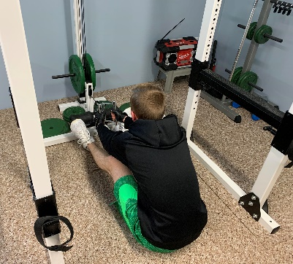
- At this point you would now release the tension in your back by easing the handles forward (lowering the weight), therefore this will result in you leaning forward to the initial position when you first grabbed the handles.

- You will now repeat for however many desired repetitions. You will not release the handles or let the weight sit down between repetitions.
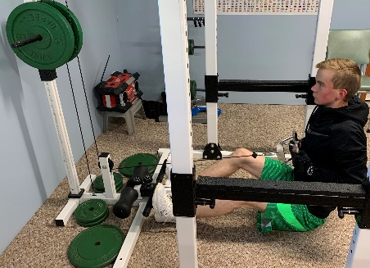

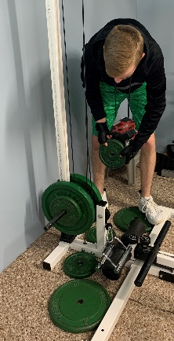
- Once you have completed your desired amount of repetitions you will then ease the weight to the bottom and release the handles. You have now completed your first set. For your next set(s) you will add enough weight to reach roughly 70-80% of your estimated maximum.

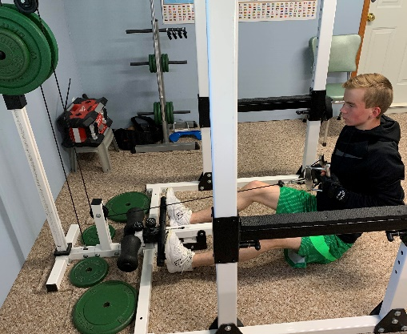
- Finally, you will now complete however many sets that are desired.

